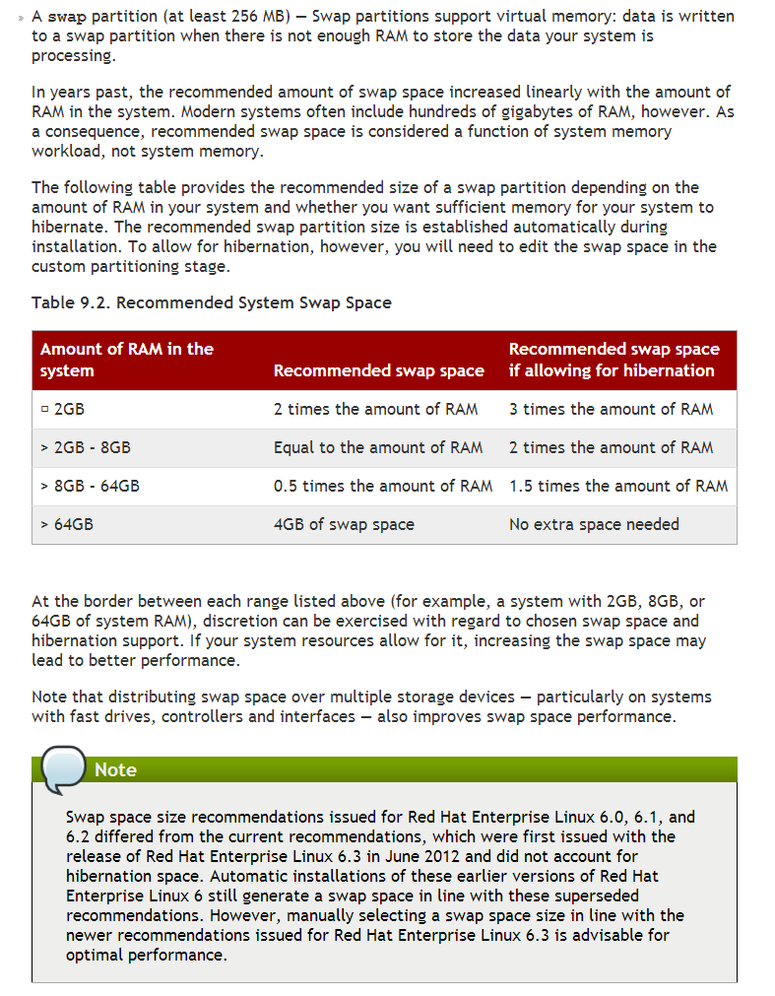

Russian documentation.
https://access.redhat.com/site/documentation/ru-RU/Red_Hat_Enterprise_Linux/6/html/Installation_Guide/index.html

https://access.redhat.com/site/documentation/en-US/Red_Hat_Enterprise_Linux/6/html/Installation_Guide/s2-diskpartrecommend-x86.html

9.15.5. Recommended Partitioning Scheme

9.15.5.1. x86, AMD64, and Intel 64 systems
We recommend that you create the following partitions for x86, AMD64, and Intel 64 systems:
- A swap partition
- A /boot partition
- A / partition
- A home partition
- A swap partition (at least 256 MB) — Swap partitions support virtual memory: data is written to a swap partition when there is not enough RAM to store the data your system is processing.
- In years past, the recommended amount of swap space increased linearly with the amount of RAM in the system. Modern systems often include hundreds of gigabytes of RAM, however. As a consequence, recommended swap space is considered a function of system memory workload, not system memory.
- The following table provides the recommended size of a swap partition depending on the amount of RAM in your system and whether you want sufficient memory for your system to hibernate. The recommended swap partition size is established automatically during installation. To allow for hibernation, however, you will need to edit the swap space in the custom partitioning stage.
- Table 9.2. Recommended System Swap Space
- Amount of RAM in the system | - Recommended swap space | - Recommended swap space if allowing for hibernation
- ⩽ 2GB | - 2 times the amount of RAM | - 3 times the amount of RAM
- > 2GB – 8GB | - Equal to the amount of RAM | - 2 times the amount of RAM
- > 8GB – 64GB | - 0.5 times the amount of RAM | - 1.5 times the amount of RAM
- > 64GB | - 4GB of swap space | - No extra space needed

- At the border between each range listed above (for example, a system with 2GB, 8GB, or 64GB of system RAM), discretion can be exercised with regard to chosen swap space and hibernation support. If your system resources allow for it, increasing the swap space may lead to better performance.
- Note that distributing swap space over multiple storage devices — particularly on systems with fast drives, controllers and interfaces — also improves swap space performance.
- Note
- Swap space size recommendations issued for Red Hat Enterprise Linux 6.0, 6.1, and 6.2 differed from the current recommendations, which were first issued with the release of Red Hat Enterprise Linux 6.3 in June 2012 and did not account for hibernation space. Automatic installations of these earlier versions of Red Hat Enterprise Linux 6 still generate a swap space in line with these superseded recommendations. However, manually selecting a swap space size in line with the newer recommendations issued for Red Hat Enterprise Linux 6.3 is advisable for optimal performance.
- A /boot/ partition (250 MB)
- The partition mounted on /boot/ contains the operating system kernel (which allows your system to boot Red Hat Enterprise Linux), along with files used during the bootstrap process. For most users, a 250 MB boot partition is sufficient.
- Important — Supported file systems
- The GRUB bootloader in Red Hat Enterprise Linux 6.5 supports only the ext2, ext3, and ext4 (recommended) file systems. You cannot use any other file system for /boot, such as Btrfs, XFS, or VFAT.
- Warning
- Note that normally the /boot partition is created automatically by the installer. However, if the / (root) partition is larger than 2 TB and (U)EFI is used for booting, you need to create a separate /boot partition that is smaller than 2 TB to boot the machine successfully.
- Note
- If your hard drive is more than 1024 cylinders (and your system was manufactured more than two years ago), you may need to create a /boot/ partition if you want the / (root) partition to use all of the remaining space on your hard drive.
- Note
- If you have a RAID card, be aware that some BIOS types do not support booting from the RAID card. In cases such as these, the /boot/ partition must be created on a partition outside of the RAID array, such as on a separate hard drive.
- A root partition (3.0 GB - 5.0 GB) — this is where "/" (the root directory) is located. In this setup, all files (except those stored in /boot) are on the root partition.
- A 3.0 GB partition allows you to install a minimal installation, while a 5.0 GB root partition lets you perform a full installation, choosing all package groups.
- Root and /root
- The / (or root) partition is the top of the directory structure. The /root directory (sometimes pronounced "slash-root") is the home directory of the user account for system administration.
- A home partition (at least 100 MB)
- To store user data separately from system data, create a dedicated partition within a volume group for the /home directory. This will enable you to upgrade or reinstall Red Hat Enterprise Linux without erasing user data files.
Many systems have more partitions than the minimum listed above. Choose partitions based on your particular system needs. Refer to Section 9.15.5.1.1, “Advice on Partitions” for more information.
If you create many partitions instead of one large / partition, upgrades become easier. Refer to the description of the Edit option in Section 9.15, “ Creating a Custom Layout or Modifying the Default Layout ” for more information.
The following table summarizes minimum partition sizes for the partitions containing the listed directories. You do not have to make a separate partition for each of these directories. For instance, if the partition containing /foo must be at least 500 MB, and you do not make a separate /foo partition, then the / (root) partition must be at least 500 MB.
Table 9.3. Minimum partition sizes
Directory | Minimum size
/ | 250 MB
/usr | 250 MB, but avoid placing this on a separate partition
/tmp | 50 MB
/var | 384 MB
/home | 100 MB
/boot | 250 MB

Leave Excess Capacity Unallocated
Only assign storage capacity to those partitions you require immediately. You may allocate free space at any time, to meet needs as they occur. To learn about a more flexible method for storage management, refer to Appendix D, Understanding LVM.
If you are not sure how best to configure the partitions for your computer, accept the default partition layout.

9.15.5.1.1. Advice on Partitions
Optimal partition setup depends on the usage for the Linux system in question. The following tips may help you decide how to allocate your disk space.
- Consider encrypting any partitions that might contain sensitive data. Encryption prevents unauthorized people from accessing the data on the partitions, even if they have access to the physical storage device. In most cases, you should at least encrypt the /home partition.
- Each kernel installed on your system requires approximately 10 MB on the /boot partition. Unless you plan to install a great many kernels, the default partition size of 250 MB for /boot should suffice.
- Important — Supported file systems
- The GRUB bootloader in Red Hat Enterprise Linux 6.5 supports only the ext2, ext3, and ext4 (recommended) file systems. You cannot use any other file system for /boot, such as Btrfs, XFS, or VFAT.
- The /var directory holds content for a number of applications, including the Apache web server. It also is used to store downloaded update packages on a temporary basis. Ensure that the partition containing the /var directory has enough space to download pending updates and hold your other content.
- Warning
- The PackageKit update software downloads updated packages to /var/cache/yum/by default. If you partition the system manually, and create a separate /var/partition, be sure to create the partition large enough (3.0 GB or more) to download package updates.
- The /usr directory holds the majority of software content on a Red Hat Enterprise Linux system. For an installation of the default set of software, allocate at least 4 GB of space. If you are a software developer or plan to use your Red Hat Enterprise Linux system to learn software development skills, you may want to at least double this allocation.
- Do not place /usr on a separate partition
- If /usr is partitioned separately from the rest of the root volume, the boot process becomes much more complex because /usr contains boot-critical components. In some situations, such as when installing on an iSCSI drive, the system will not boot.
- Consider leaving a portion of the space in an LVM volume group unallocated. This unallocated space gives you flexibility if your space requirements change but you do not wish to remove data from other partitions to reallocate storage.
- If you separate subdirectories into partitions, you can retain content in those subdirectories if you decide to install a new version of Red Hat Enterprise Linux over your current system. For instance, if you intend to run a MySQL database in /var/lib/mysql, make a separate partition for that directory in case you need to reinstall later.
- UEFI systems should contain a 50-150MB /boot/efi partition with an EFI System Partition filesystem.
The following table is a possible partition setup for a system with a single, new 80 GB hard disk and 1 GB of RAM. Note that approximately 10 GB of the volume group is unallocated to allow for future growth.
Example Usage
This setup is not optimal for all use cases.
Example 9.1. Example partition setup
Table 9.4. Example partition setup
Partition | Size and type
/boot | 250 MB ext3 partition
swap | 2 GB swap
LVM physical volume | Remaining space, as one LVM volume group

The physical volume is assigned to the default volume group and divided into the following logical volumes:
Table 9.5. Example partition setup: LVM physical volume
Partition | Size and type
/ | 13 GB ext4
/var | 4 GB ext4
/home | 50 GB ext4

